**EBS Assignment**

**A cloud administrator wants to verify the persistence of data stored on an Amazon Elastic Block Store (EBS) volume after detaching it from one EC2 instance and attaching it to another. The objective is to understand whether EBS retains files and directories even after the original EC2 instance is terminated.**

To conduct this experiment, the administrator will:

Create an EBS volume and attach it to an EC2 instance.

Mount the volume, format it (if necessary), and create test files.

Terminate the EC2 instance to observe if the data remains intact.

Attach the same EBS volume to a new EC2 instance and verify whether the files persist.

====================================================================================================================

**Tasks:**

1. Ensuring Data Persistence

Create an EBS volume, attach it to an EC2 instance, and store sample files.

Verify if the data remains intact after detaching and reattaching the volume.

* Created a Test volume
* Create a EC2 instance, which will create a default EBS.
* Now we need to attach the created the EBS volume to the EC2 instance.  
  **Note:** The Volume and the EC2 has to be on the same AZ  
  After attaching the volume  
  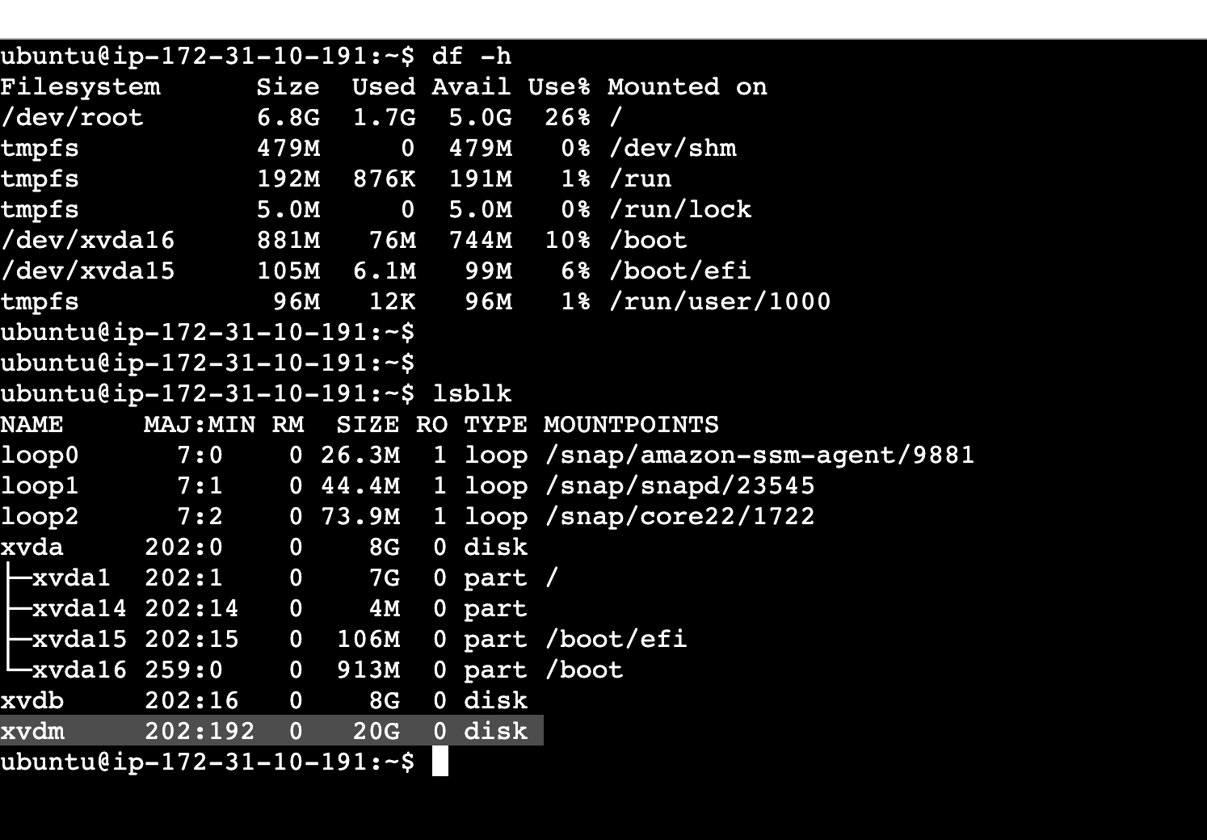
* We need to mount the EBS to the EC2. For this we need to create an EFS
  + Create a directory i.e mount point (mkdir -p test)
  + Create a file system (sudo mkfs -t ext4 /dev/xvdm)
  + Verify if the file system got created or not (sudo file -s /dev/xvdm)
  + Mount the EBS volume to the mount point i.e test (sudo mount /dev/xvdm test/)
  + Now we can see this volume  
    A screenshot of a computer program

    AI-generated content may be incorrect.
* Created sample files and directories   
  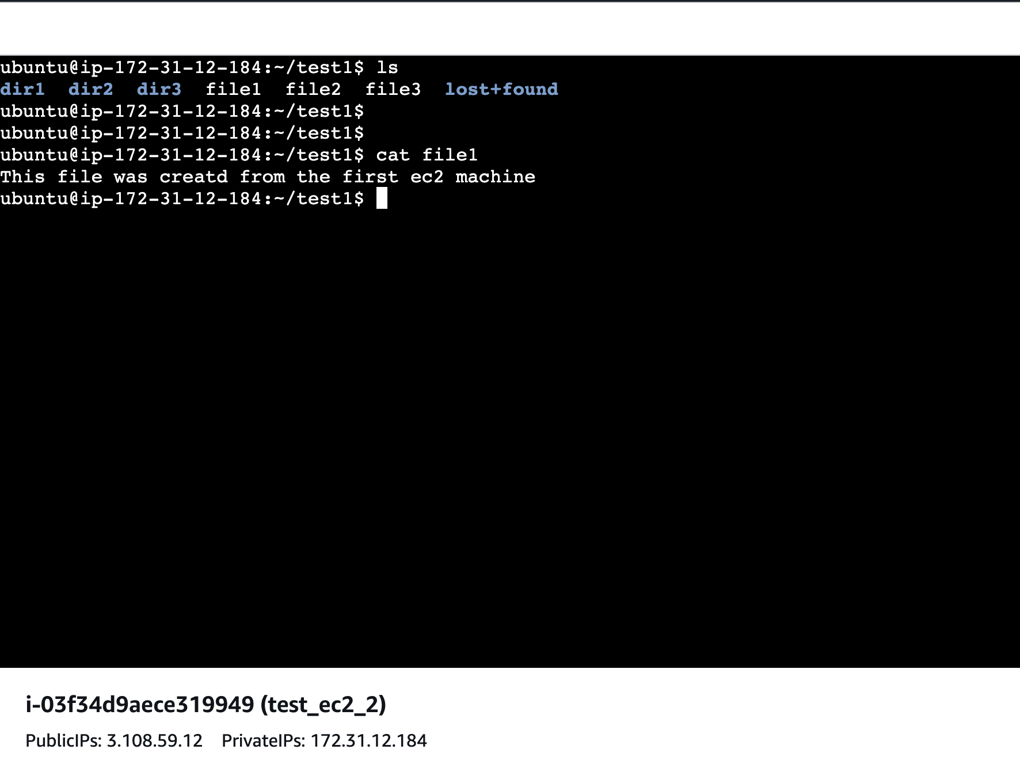
* Stop the instance and detach the volume from the ec2
* Create a new ec2 machine, attach the same volume, create a folder to mount and do the mount.  
  Note: Do not create a new file system. We have already created it earlier.  
  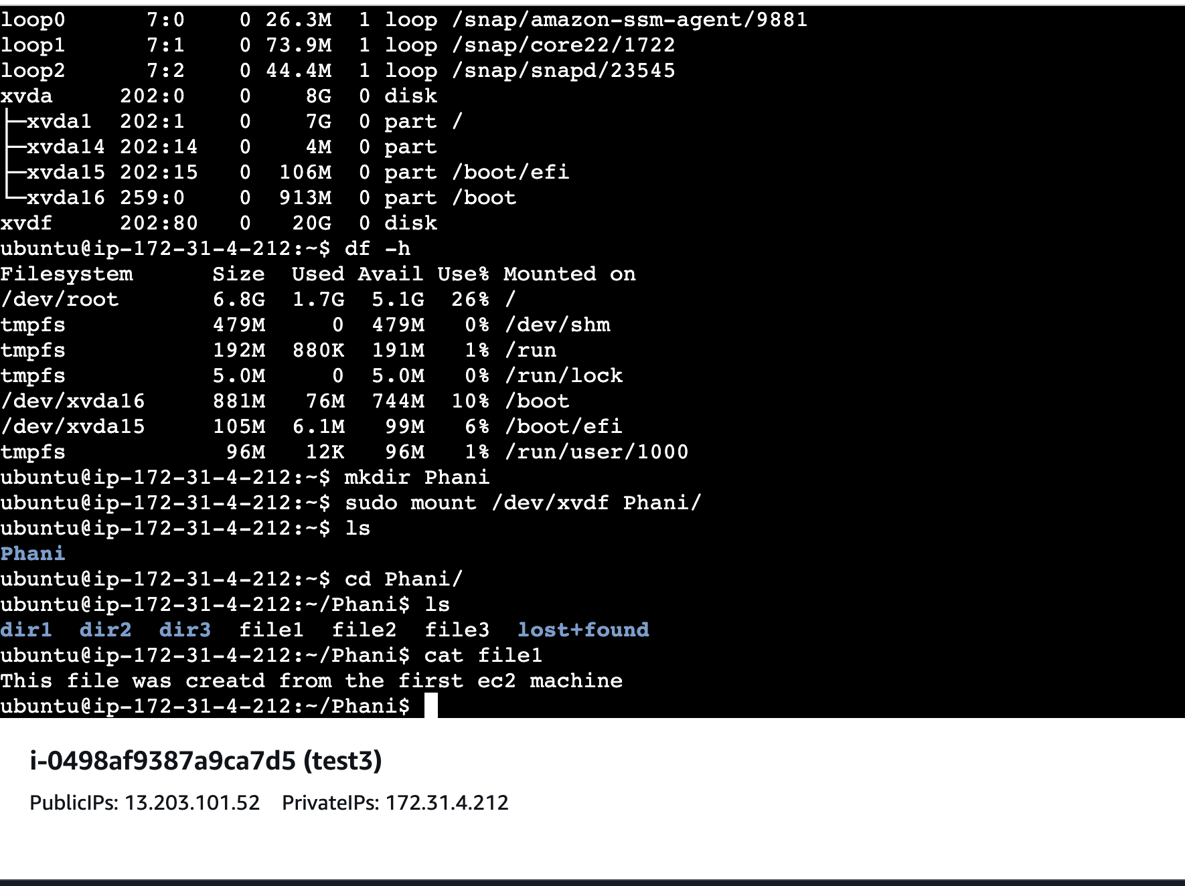
* The data is in Intact.

1. Creating a Backup

Take an EBS snapshot and analyze if it is incremental or full.

Check how long the snapshot creation takes and its impact on storage.

* Create a snapshot for the volume  
  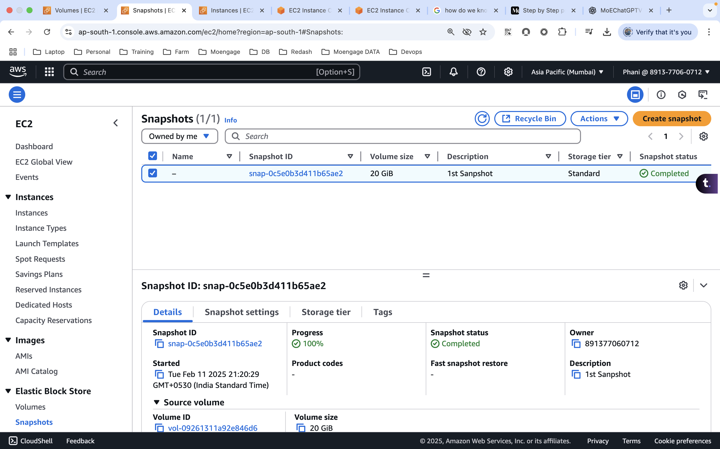

1. Restoring Data from a Snapshot

Create a new EBS volume from the snapshot.

Attach it to a different EC2 instance and verify if the original data is still accessible.

* Create volume from the snapshot
* Attach the newly created volume to the ec2 instance
* create a directory and mount the EBS to it
* mkdir -p NPR
* sudo mount /dev/xvdf NPR/  
  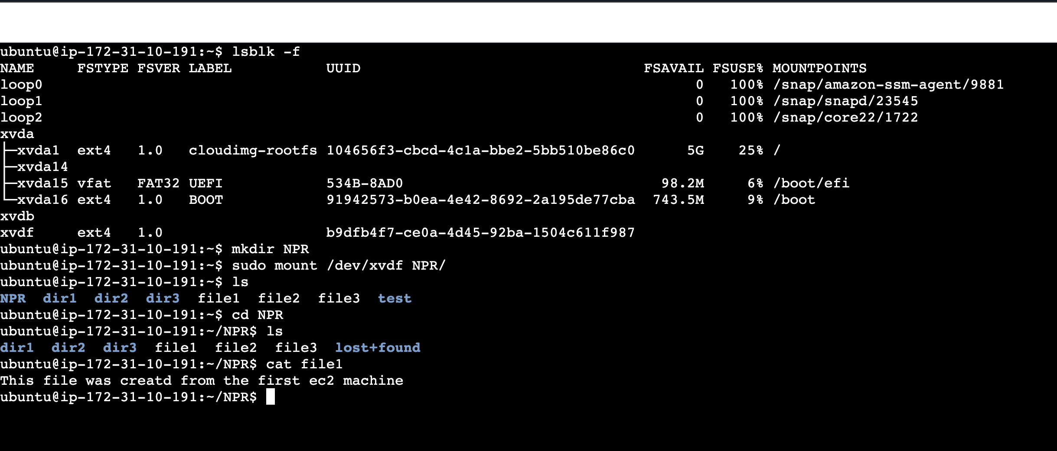
* The original data is still accessible

1. Testing Disaster Recovery

Simulate failure by deleting the original EBS volume.

Restore data from the snapshot and ensure business continuity.

* Force detach the volume from the ec2  
  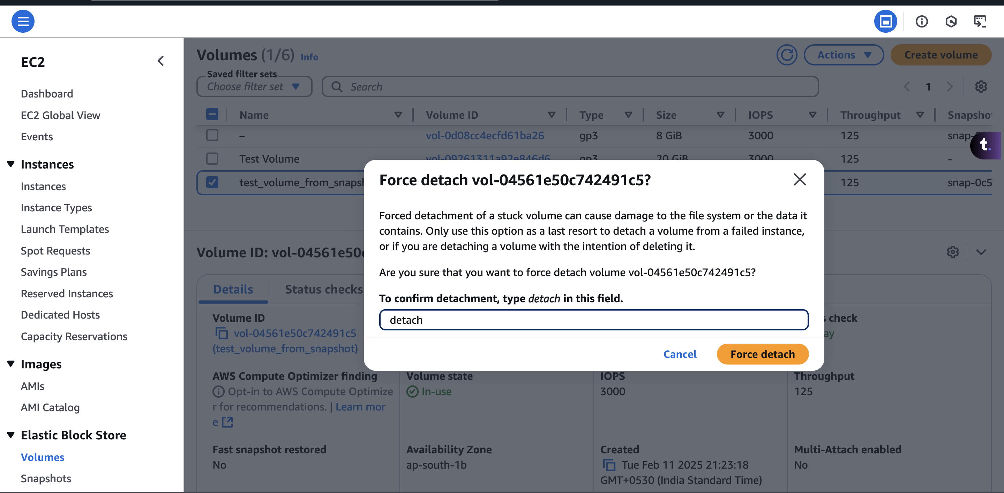
* Cannot access the EBS  
  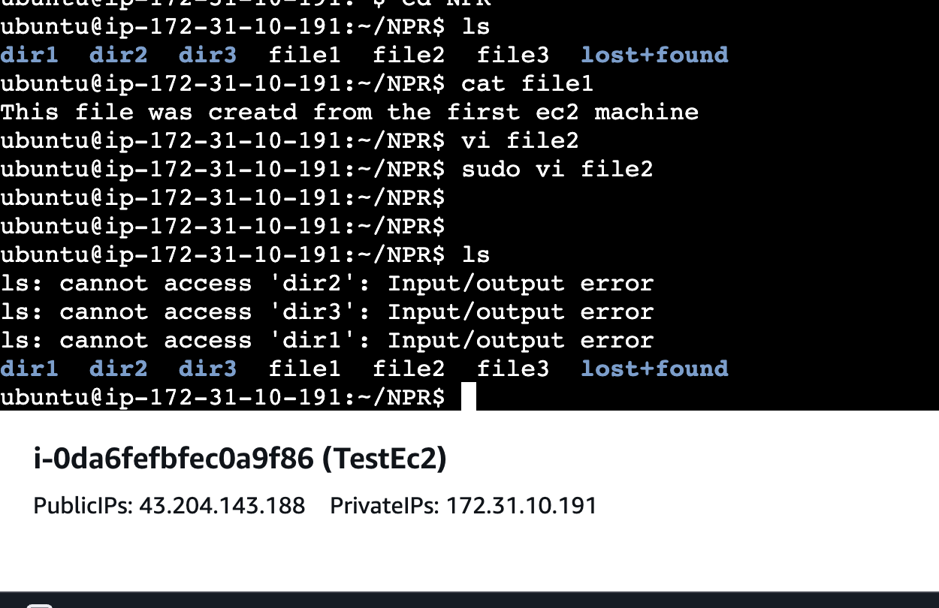
* Delete the EBS and create a new EBS from the snapshot and attach it to the ec2 instance.

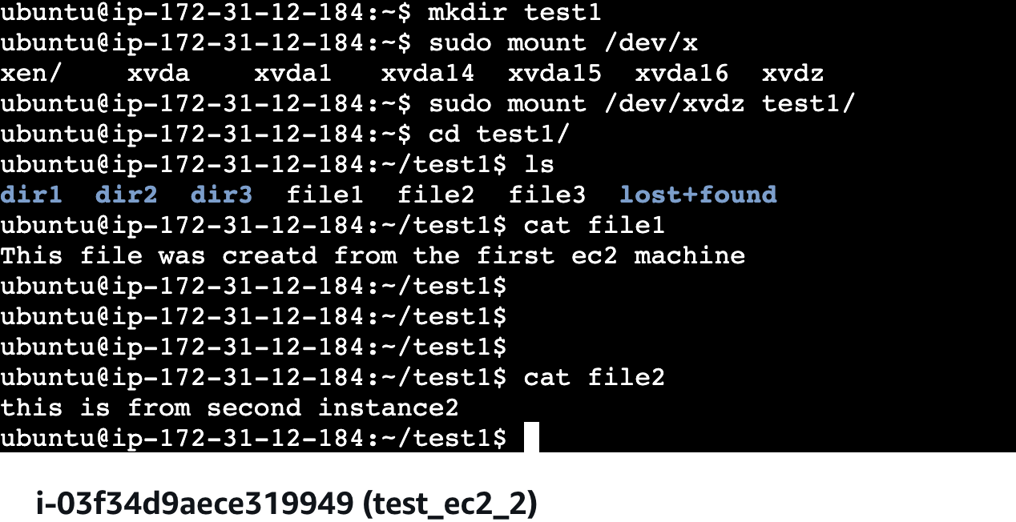

* The data is available

1. **Automating Backups**

Set up AWS Lifecycle Manager to automate snapshot creation and retention.

* Select the volume to which you want to automate the backup and under actions, select snapshot lifecycle policy  
  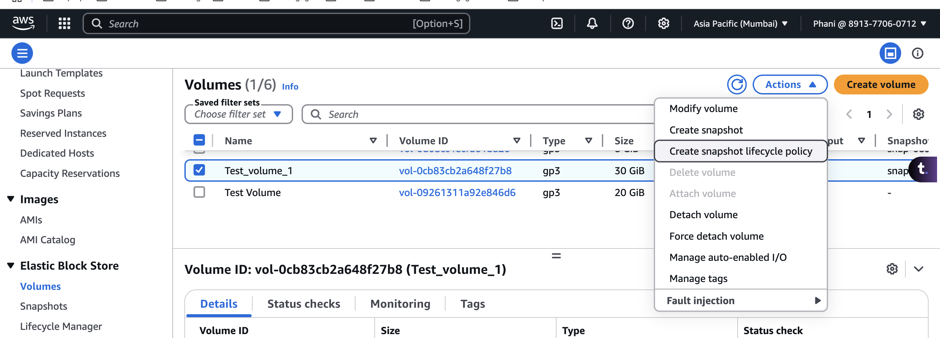
* Provide the details and configure the schedule. (We can have a max of 4 schedules)  
  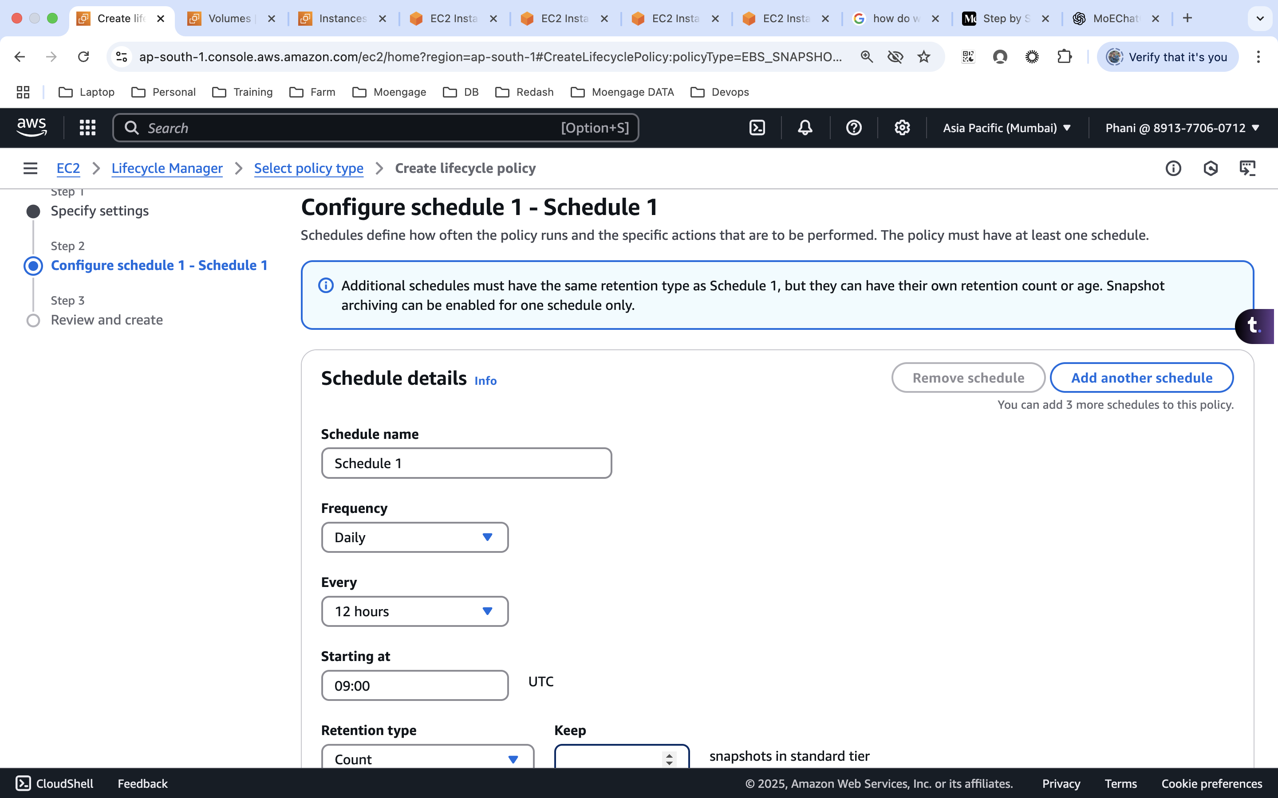

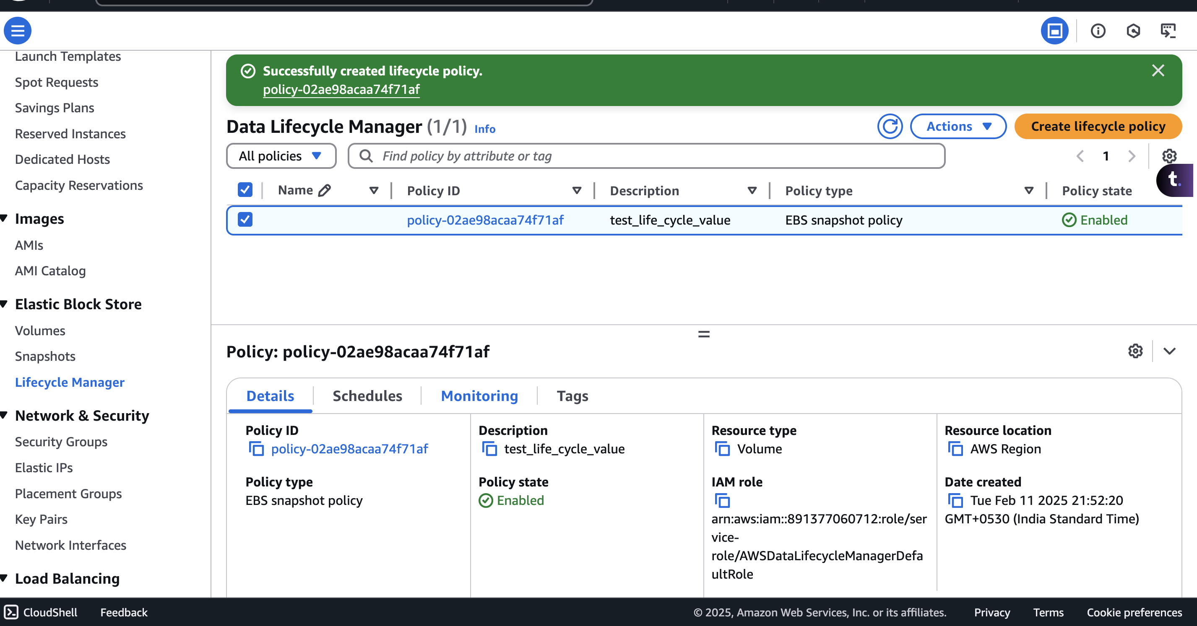

1. **Cross-Region & Cross-Account Backup**

Copy the snapshot to another AWS region/account and explore its use cases.  
  
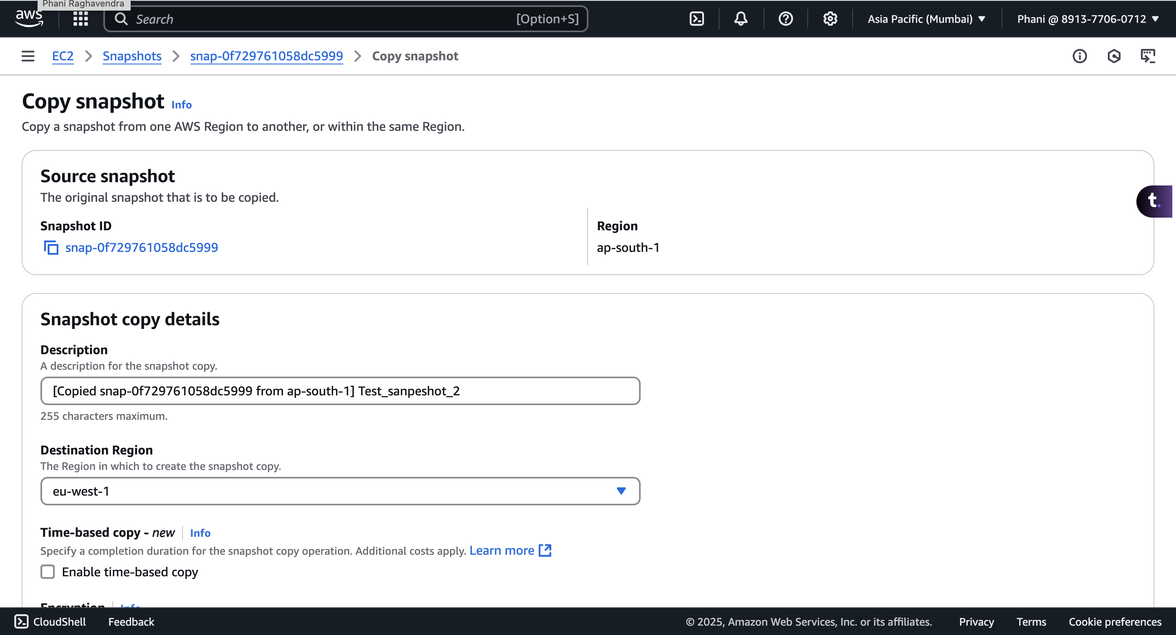  
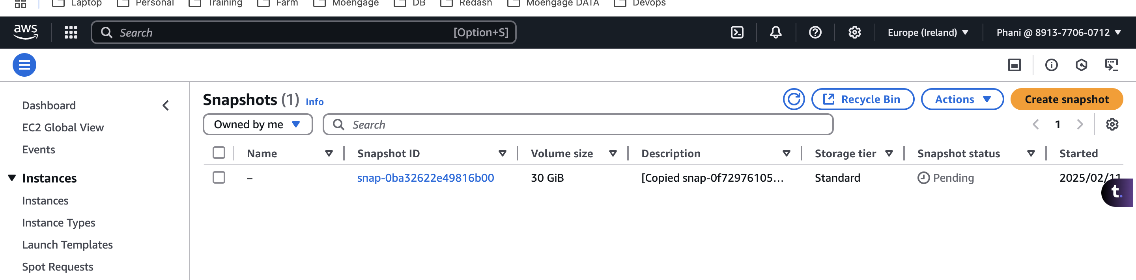

To share it across the accounts, click on the modify permissions of the snapshot and provide the account id.  
